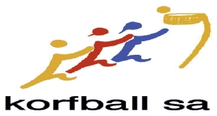
“SUMMER CLASSIC” KORFBALL TOURNAMENT

Date: 23rd February
Time: 10am form teams etc. 11am start
Venue: Marion Sports and Community Club
Costs: $50 per team
Comp: Mixed grade teams (no more than 4 A-grade players per team on the court) Round robin aiming at club based teams, but happy for others to enter in a team.

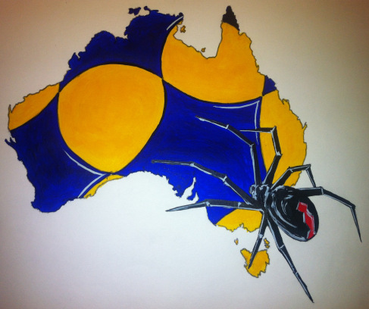It will include the Sydney City Redbacks team for their first interstate tournament.

If you’re not playing come along and see some fun korfball and ……….

There will also be a dinner at the Marion Club after the event. Friends and Family are most welcome however we do need numbers in advance. (Meals are around $15 - $20).
Contact Karina at development@sa.korfball.org.au or on 0409251185
for dinner bookings

